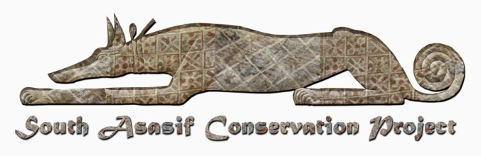

# South Asasif Conservation Trust

## Patrons, Friends and Donation Form - 2016

|  |  |  |  |
| --- | --- | --- | --- |
|  | Amount | Name(s) for Friends/Patrons/Sponsors | Total |
| Sustaining Sponsor(s) 2016 | £1000 |  | £ |
| Patron(s) 2016 | £100 |  | £ |
| Friend (s) 2016 | £20 |  | £ |
| Additional Donation for 2016 season | £ |  | £ |
|  |  |  |  |
| GRAND TOTAL | £ |  | £ |

I enclose cash / a cheque payable / bank transfer to ‘South Asasif Conservation Trust’ for £.........

**Full Name(s)** ................................................................................................................................................................................

**Address** ......................................................................................................................................................................................

**Postcode** ……………………. **Tel.**.......................................... **Date.** …………………………………………………………

**Email** ...................................................................................................................................................................................

**In order to Gift Aid your donation you must tick the box below:**

I want to Gift Aid my donation of £______________ to the South Asasif Conservation Trust

*I confirm that I am a UK taxpayer and understand that if I pay less Income Tax and/or Capital Gains Tax in the current tax year than the amount of Gift Aid claimed on all my donations it is my responsibility to pay any difference. * Please delete if this does not apply

Please notify the South Asasif Conservation Trust if you:

* want to cancel this declaration
* change your name or home address
* no longer pay sufficient tax on your income and/or capital gains

If you pay Income Tax at the higher or additional rate and want to receive the additional tax relief due to you, you must include all your Gift Aid donations on your Self-Assessment tax return or ask HM Revenue and Customs to adjust your tax code.

All cheques must be in British Pounds Sterling drawn on a UK bank. Details for electronic transfer can be provided on request. Please send to Treasurer, South Asasif Conservation Trust, 3 Tithe Barn, Merton, Bicester, Oxfordshire, OX25 2NF